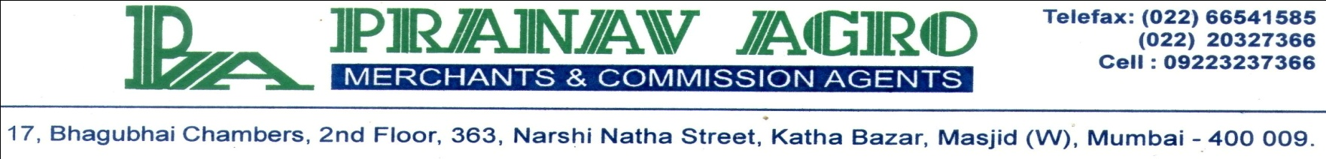

Certificate of Analysis
Product Name: Castor Oil BSS Grade

Sr.No. | Properties | Test Report
1. | Appearance | Pale Yellow Viscous, Clear Liquid
2. | Moisture, Impurities & Volatile Matters | 0.14%
3. | Colour in 5 1/4 " cell  (Lovibond) | Y – 16.0  R – 1.6
4. | FFA | 0.80
5. | Acid Value (mg KOH/g) | 1.60
6. | Specific Gravity @ 25° C | 0.959
7. | Iodine Value | 86.00
8. | Saponification value | 180.00
9. | Hydroxyl Value | 160.00

For PRANAV AGRO

