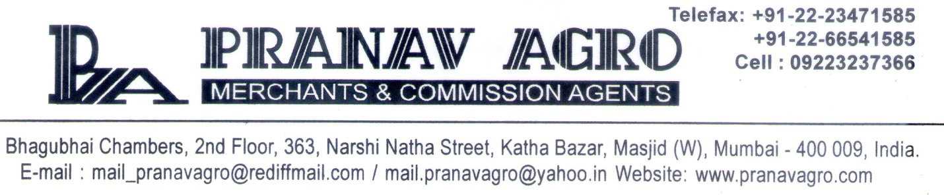Certificate Of Analysis

Product Name: Refined Soya Bean Oil

Sr.No. | PARAMETER | SPECIFICATION | ACTUAL REPORT
1. | APPEARANCE | Golden Yellow Clear Liquid | Golden Yellow Clear Liquid
2. | Moisture , Impurities & Volatile Matters. | 0.10 % Max |  | 0.06 %
3. | Peroxide Value (Meq/Kg) | 0.5 Max |  | 0.30
4. | F.F.A | 0.25 Max |  | 0.05
5. | Iodine Value | 121-140 |  | 130.00
6. | Saponification Value | 189 - 195 |  | 192.00

For PRANAV AGRO

Authorized Signatory

